How to Facebook Live

# About

The Facebook Live application is a social media integration for the OPOSORO ONO Robot. With this app you can make the robot read & react to Facebook status updates and comments or even start your own Facebook live video stream!

# User Manual

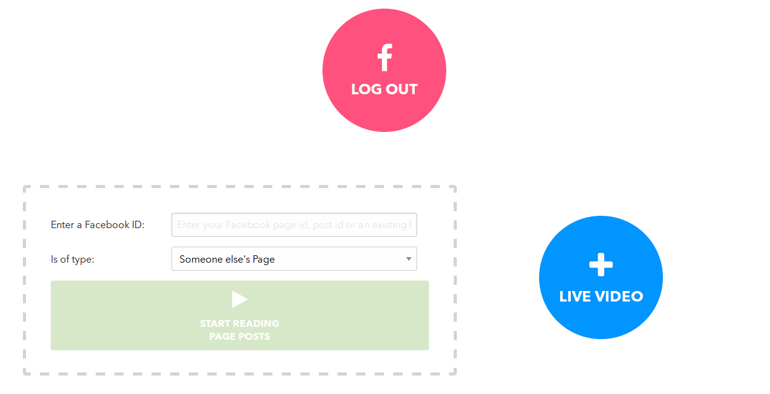The first button you see is to log in to- or log out of Facebook. A Facebook login is required to access Facebook data. On first visit you’ll see a Facebook pop-up window asking you to log in. If you’re successfully logged in, you’ll be automatically logged in on next visits and see the screen below:

## The Box

In the left box, the “Start Reading …” button should be disabled as long as you haven’t entered a valid Facebook id. You probably wonder where to get one. Well, we’ve put in some features to get you started. To obtain the Facebook id of a page or post, please read “The Facebook Graph API Explorer” section of [./facebook_live_user_manual.md](facebook_live_user_manual.md)

1. **Option 1:** “Someone else’s Page”, requires a Facebook id and will retrieve, read and react to the 25 most recent posts of the desired page.
2. **Option 2:** “My Page”, when you select this, your own Facebook user id will appear in the input field above it and will be usable to start retrieving your page’s posts. The robot can read & react to your most recent posts.
3. **Option 3:** “A (Live) Video”, requires the Facebook id from an already **existing** Facebook video and will read- & react to the most recent comments posted to the video.
4. 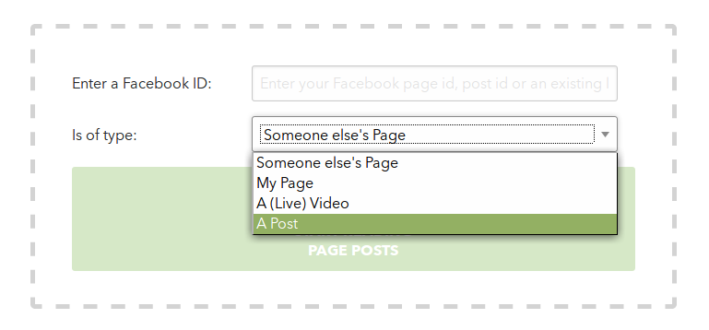**Option 4:** “A Post” requires a Facebook post id. The robot will read & react to the comments posted there.

### Option 2 is selected

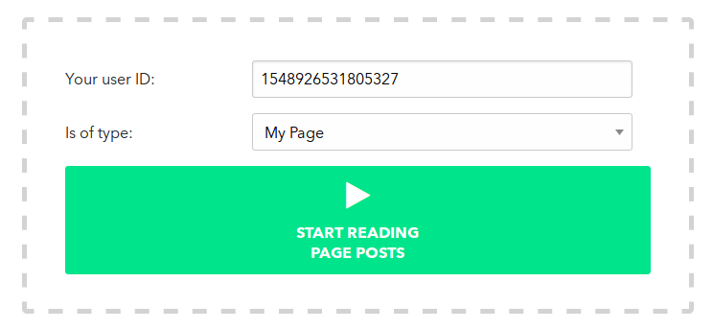Notice how your own user id, automatically gets filled in. You can now start fetching your most recent page’s posts.

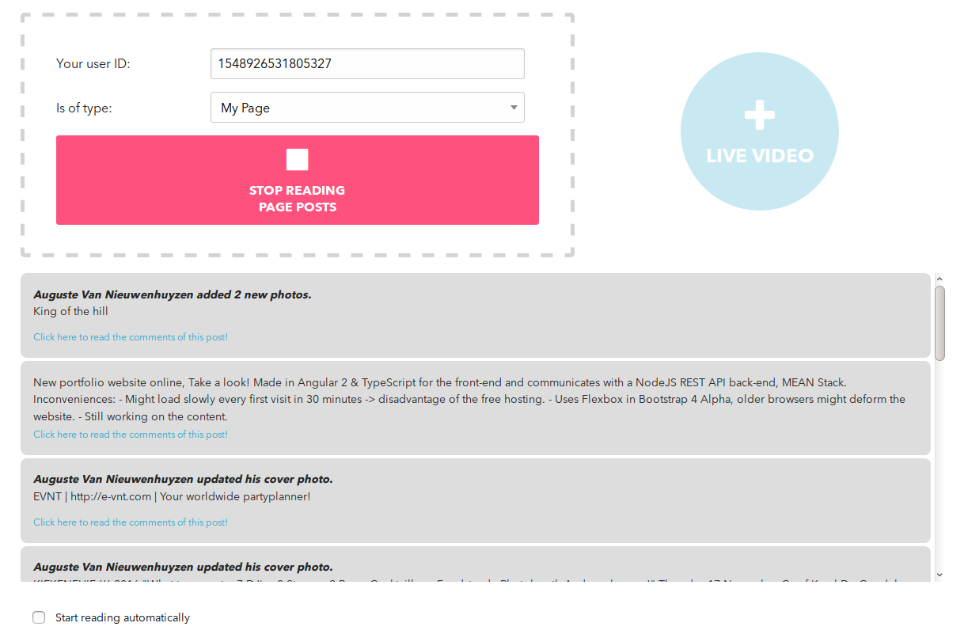Press “START READING PAGE POSTS”, this will result in something like this:

### A lot going on

You see that your most recent page’s posts have appeared. You could now post a new Facebook status and it will be read out loud by the robot. Follow these steps:

1. Check the bottom left checkbox.
2. 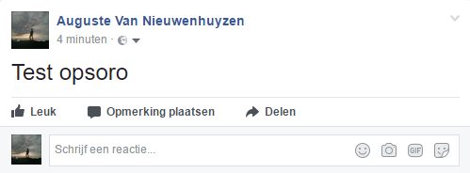Post a new Facebook status on **your** Facebook profile. It will appear as the top most post in your application and be read out loud.

Application updated: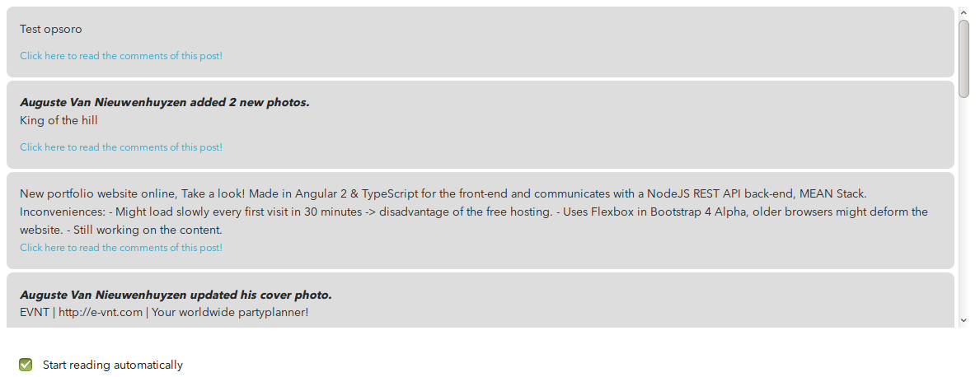

Optional feature: you can click the blue-ish link to paste that Facebook post id into the input field, notice that it already started retrieving the comments!

**Extra:** you can follow the same steps when using another page’s Facebook id.

## A Post’s Comments

When you try to retrieve a post’s comments when there none, the display will say so.

Notice a few things here:

1. The Facebook id changed in the input field.
2. The type changed to “A Post”, this gets detected automatically.
3. The text “Likes: 0” appeared.
4. 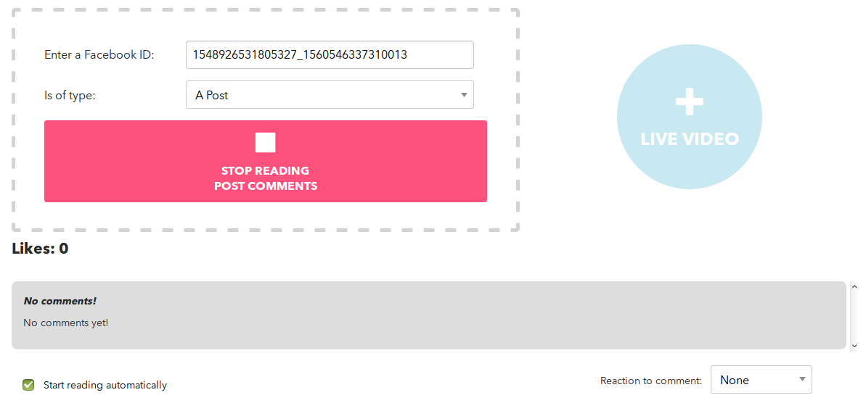In the bottom right corner, a selectbox appeared to make the robot react to incoming comments.

### Add comments to your post

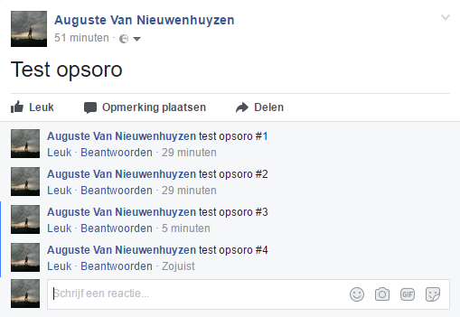Adding comments on you Facebook post, will update the application and read the comments out loud if there is a new one. Let’s try that out.

1. Post some comments to your post.
2. Listen, you’ll hear the robot reading them. Make sure your volume is turned up!

### React to new comments

Everytime a comment is detected you can choose how you want the robot to react.

Let’s test it by settings it to “laughing”. Notice that I liked my own post and it updated in the upper left corner “Likes: 1”.

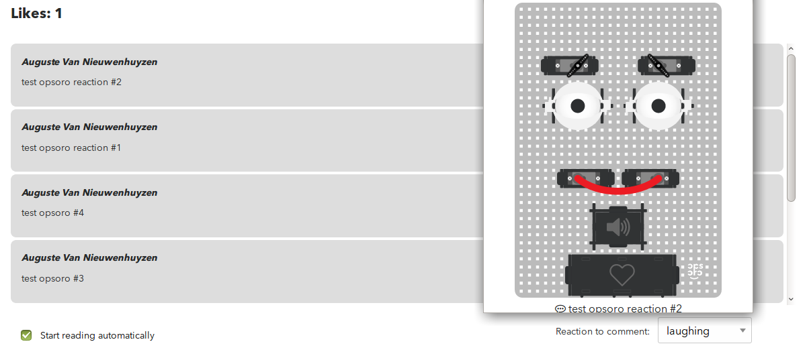I’m demonstrating the emotion change on a virtual robot but you should see it happen on a real one.

## New Facebook Live Video

In this application you can also start a new Facebook live stream and make the robot react to the comments & reactions, the live stream receives.

### External Streaming Software

It is recommended to use external streaming software to set-up your newly created Facebook live stream.

I’ll cover OBS as external streaming software in this guide.

### OBS

OBS (Open Broadcasting Software) is also referenced to and shown in the Facebook documentation, download link: <https://obsproject.com/download>

Follow this link to set-up OBS: <https://github.com/jp9000/obs-studio/wiki/Install-Instructions>

Once it's downloaded an "Auto-Configuration Wizard" will pop-up, make good use of this. Make sure you set the streaming service to "Facebook Live". You’ll now need a **stream key**. You can retrieve this key through a Facebook dialog. So go back to the application and click the button:

“+ LIVE VIDEO”. This will show the following pop-up, adjust your settings and click “Next” or in my case “Volgende”.

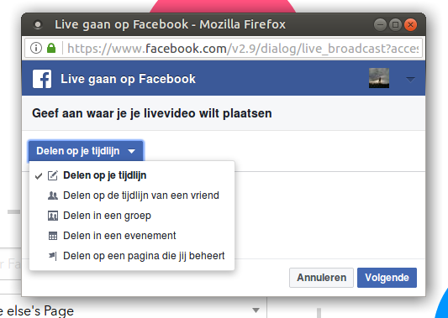

You have now successfully **created** a **new** Facebook live stream! Next up is **connecting** to it with **OBS**.

You’ll see the form changing with your new video’s data.

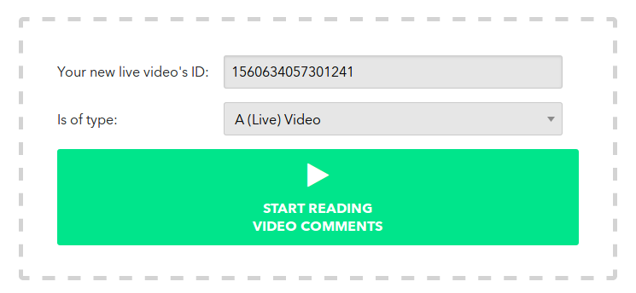

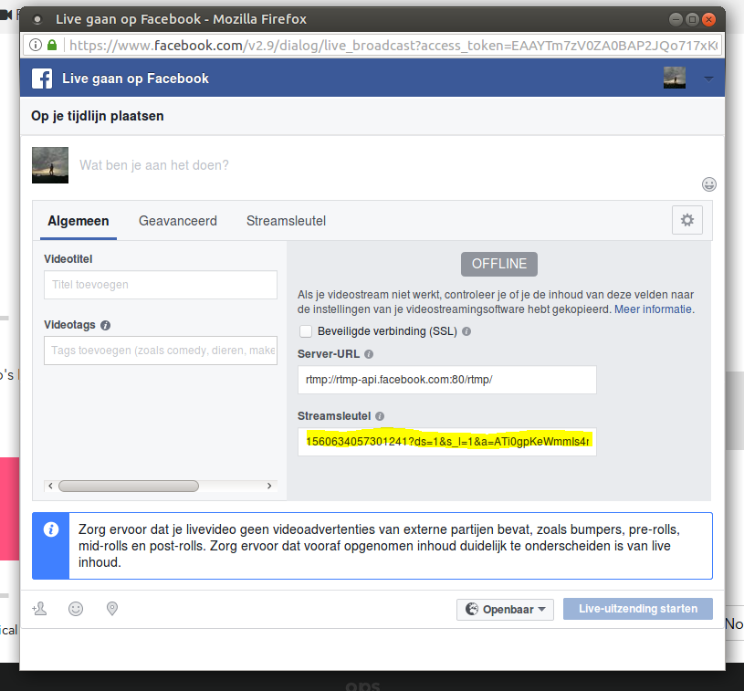Click the button “Start Reading Video Comments” to continue. This will open up another pop-up window where you’ll retrieve your **stream key** and can start your stream.

1. Open up OBS again.
2. Go to “Settings” > “Stream”.
3. Paste in your new stream key from the Facebook dialog.
4. Press “Ok” and start your stream.
5. Wait for OBS to connect to the stream.

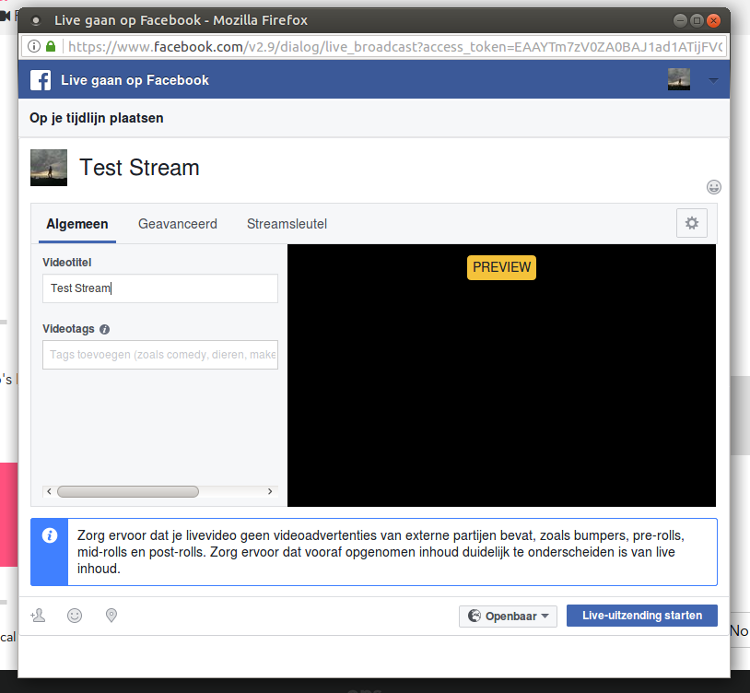If OBS has successfully connected to the stream you’ll see it here:

Start your live stream!

### Comments on video

Once your stream is up you’ll see a lot changes in the app. An embedded video to the left, comments to the right and a new checkbox:

Check this and let’s see what it does.

1. Navigate to your live stream and place a reaction on it or a like. Also make some comments on it just for fun.

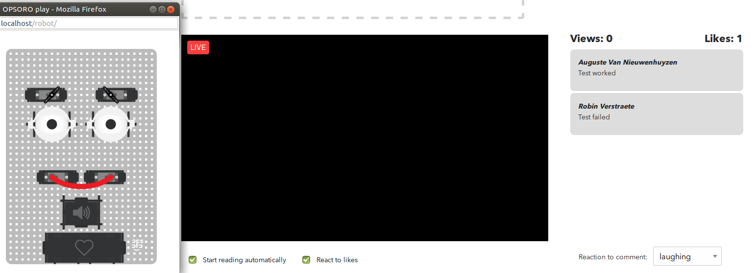The robot should show an expression and will read the comments out loud.

We have now covered about all there is to the application. Some last instructions:

1. Press to stop fetching comments, stop your stream in OBS.

You’ll notice the video’s id is still filled in, in the input field. We can use this to test the behavior for when you’d enter an **existing** Facebook video id.

1. Press “Start Reading Stream” to do it over. It will pick-up from where you left off.

### One last feature

You can also get the post from other Facebook pages but you’ll need the id. This is not retrievable through the application but you can follow my well document .md file about the Facebook Graph API: [./facebook_live_user_manual.md](facebook_live_user_manual.md)

The application adapts it’s lay-out pretty well to your actions. Have fun with it!